ALO SAVE IBU

TECHNICAL REPORT

Key Insights from SAMCO’s 2019 Performance Analysis Report

Purpose of the Analysis

The SAMCO Supermarket Sales Dashboard was developed to provide a comprehensive, interactive overview of sales performance across time, regions, cities, and sales personnel.
Its primary objectives are to:

Monitor overall revenue performance
Identify regional and seasonal sales trends
Evaluate salesperson productivity
Support data-driven strategic decision-making

Target Users
This dashboard is designed for:
Senior Management
Sales Managers
Regional Managers
Business Analysts
Operations and Strategy Teams

Key Performance Indicators (KPIs)

Total Revenue
Total sales revenue generated during the year
Total Orders Raised
Number of customer orders processed
Total Shipping Fee
Total revenue generated from shipping fees
Monthly Revenue
Revenue trend across the 12 months
Revenue by Region
Sales performance across North, East, South, and West
Quantity by Region
Sales volume distribution by region
Revenue by Salesperson
Individual contribution to total revenue

Dashboard Components & Visuals
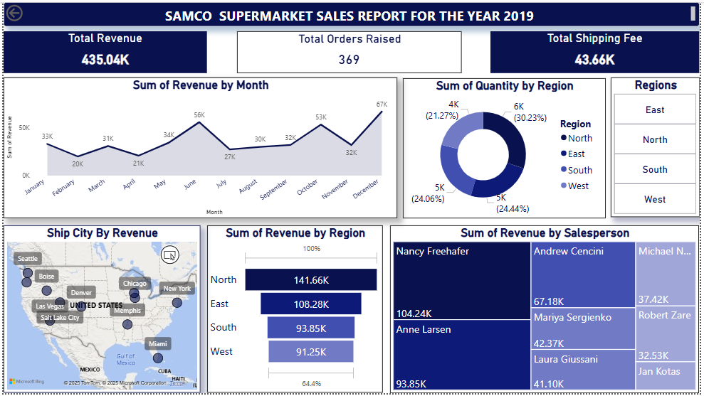
Total Revenue: 435.04K
Total Orders Raised: 369
Total Shipping Fee: 43.66K
These provide a quick performance snapshot at a glance.

Monthly Revenue Trend
Visualization: Line/Area Chart
Displays revenue fluctuations from January to December
Highest revenue recorded in December (67K)
Lowest revenue observed in February (20K)
Insight:
Revenue exhibits seasonality, with mid-year and end-year peaks.

Quantity Sold by Region
Visualization: Donut Chart
Shows proportional distribution of quantities sold across regions
Sales volumes are relatively balanced, with no extreme dominance
Insight:
Demand is consistent across regions; revenue differences likely stem from pricing or product mix.

Revenue by Region
Visualization: Horizontal Bar Chart
Region
Revenue
North
141.66K
East
108.28K
South
93.85K
West
91.25K
Insight:
The North region leads revenue, contributing over one-third of total sales.

Shipping City by Revenue
Visualization: Geographic Map
Displays revenue distribution across major U.S. cities
High-performing cities include urban and commercial hubs
Insight:
Urban centers drive a significant share of sales activity
.
Revenue by Salesperson
Visualization: Treemap
Highlights individual performance contributions
Top salesperson contributes over 100K in revenue
Revenue is concentrated among a few high performers
Insight:
Sales performance is uneven, indicating opportunities for knowledge sharing and training.

Filters & Interactivity
The dashboard includes interactive slicers for:
Region (North, East, South, West)
These filters allow users to:
Drill down into specific geographic performance
Compare regions dynamically
Support focused regional analysis

Key Insights Summary
SAMCO generated 435K in annual revenue from 369 orders
Revenue peaks occur in June and December, indicating seasonal demand
The North region dominates revenue, despite balanced sales volumes
Sales productivity varies significantly across sales personnel
Shipping fees form a meaningful portion of total revenue

Business Implications
Seasonal demand requires proactive inventory and staffing planning
Regional pricing or product strategies may need optimization
Heavy reliance on top performers introduces performance risk
Growth opportunities exist in underperforming regions and cities
Recommendations
Leverage Peak Seasons
Plan promotions, inventory, and staffing around June and December peaks.
Replicate Top Sales Strategies
Document best practices from high-performing salespeople and scale across teams.
Optimize Regional Strategy
Review pricing and product mix in lower-revenue regions.
Strengthen Secondary Markets
Use targeted marketing to grow revenue outside major urban hubs.
Monitor Shipping Fee Impact
Test free-shipping thresholds or bundled offers to increase order value.
Limitations
Data reflects only one calendar year
Customer demographics and product-level details are not included
External factors (promotions, economic conditions) are not captured
Conclusion
The SAMCO Sales Dashboard successfully transforms raw transaction data into actionable insights. By aligning sales strategy, regional focus, and performance management with these findings, SAMCO can enhance revenue growth and operational efficiency.

